Searches/Filters
In JIRA groups of samples are selected via Searches/Filters; in the Issue Navigator. JIRA refers to the criteria currently being used as a Search and to stored criteria as Filters. The navigator is opened by clicking 'Search for Issues' in the 'Issues' drop-down menu.
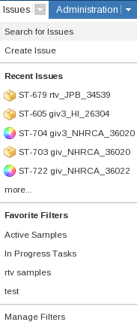
Issues drop-down menu
In the Issue Navigator the samples can be sorted and filtered based on a number of criteria. The bar on the left (the Search Bar) contains the controls for creating (New), modifying (View), storing and retrieving (Manage) Searches/Filters.

Starting a new Search
Selecting New(1) in the Search Bar clears any existing criteria and starts an empty search. With no criteria the new search would select all of the Issues in JIRA. To reduce the selection criteria are added. These are controlled through the forms in the Search Bar. The 'Project' (2) and 'Issue Type' (2) are special as they control not only what is selected but also which fields are included in the search bar and the results table.
If 'Project' and/or 'Issue Type' have been changed a dialog appears below the 'Issue Type' (3). Clicking on the link will update the available criteria in the Search Bar to include fields that are unique to the Project or Issue Type.
If no further criteria were added then the Search shown in the image below would select all Samples in Sample Tracking.
Once all the criteria have been selected there are two submit buttons
- [View >>] Updates the table of Issues
- [View & Hide] Updates the table of Issues and closes the Search Bar
The submit buttons appear both near the top of the Search Bar and at the bottom of the Search Bar.
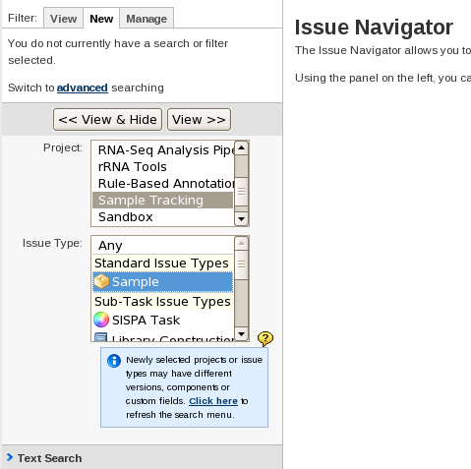
Search Side-bar
1
4
2
2
3
Clicking 'View >>' (4) submits the search and the first 50 matching Issues will be displayed. Obviously if less than 50 match then all of the matches will be returned. The table of Issues contains a number of columns of data on each issue. The columns shown are determined by a combination of the Issue Type(s) selected and a users settings. Configuring which columns appear is done from the 'Manage Filters' screen and is covered later in XXXXXXXXXXX.
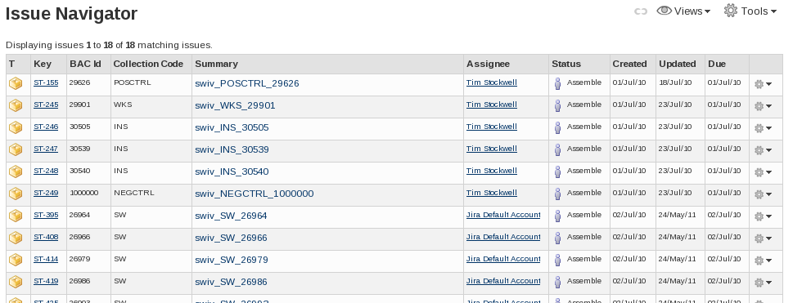
Search results
WARNING
In the Search Side-bar, in the 'Issue Attributes' section, 'Resolutions' has a list of possible values that includes 'Unresolved'. Setting 'Resolution' to 'Unresolved' selects all of the Issues and Sub-types that are not closed. As an Unresolved Sample is not expected to have any further work carried out it is considered to be closed. To select Samples that are Unresolved; select 'Unresolved' for the 'Status' and 'Any' for the 'Resolution'.
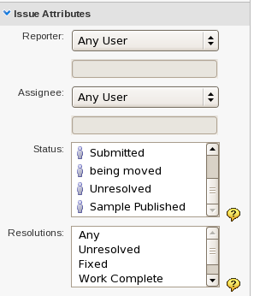
The two different 'Unresolved' types

Filters: Creating
Filters are stored Searches. They are useful to quickly switch between common searches without having to re-setup the criteria. They are also used as a way to set criteria for other modules, such as Subscriptions and Reports.
Searches can be shared, allowing groups to use the same selection criteria. When searches are shared the following caveats apply:
- Only the creator of the Filter can modify the Filter
- The creator can modify, including delete, the Filter even if others are still using it.
Once a Search has been modified and used an option to 'Save' (5) the Search will appear at the top of the Search Side-bar.
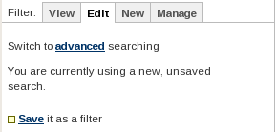
5

A Modified Search
If the Search is based on an existing Filter then a red square appears next to the tabs at the top of the Search Side-bar to indicate that there are unsaved modifications.
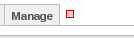
The red 'Warning Unsaved Filter' square.
Stored Searches are referred to as Filters in JIRA. When saving a Filter the summary is shown at the top of the Search Side-bar. It contains a bullet point for each property of the Filter (6).
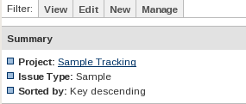
6
7

Filter Summary (Top of the Search Side-bar)

The Filter must be named and can have a description.
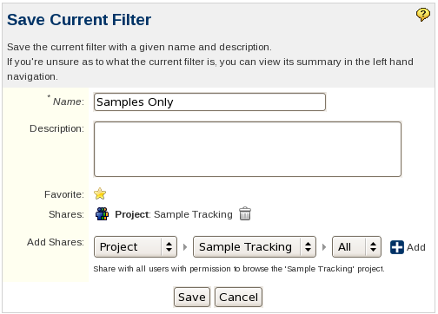
The Save Current Filter Form

Stored Filters can be made available to others. Sharing can be done in several ways; to named groups, to users/developers/administrators of a given project or to everyone. Project based shares will probably be the most helpful.
Note: The Share is only added when the button is pressed. 'Save' does not create any un-added Shares.

This number depends on the user's settings

